Module 2 Assignment 2

1. Write the C# code to display “<n> minute(s) ago" if difference between both dates is less than an hour and “<n> hour(s) ago" if the difference is less than a day and “<n> day(s) ago" if the difference is less than a month and the date if the difference is more than a month.

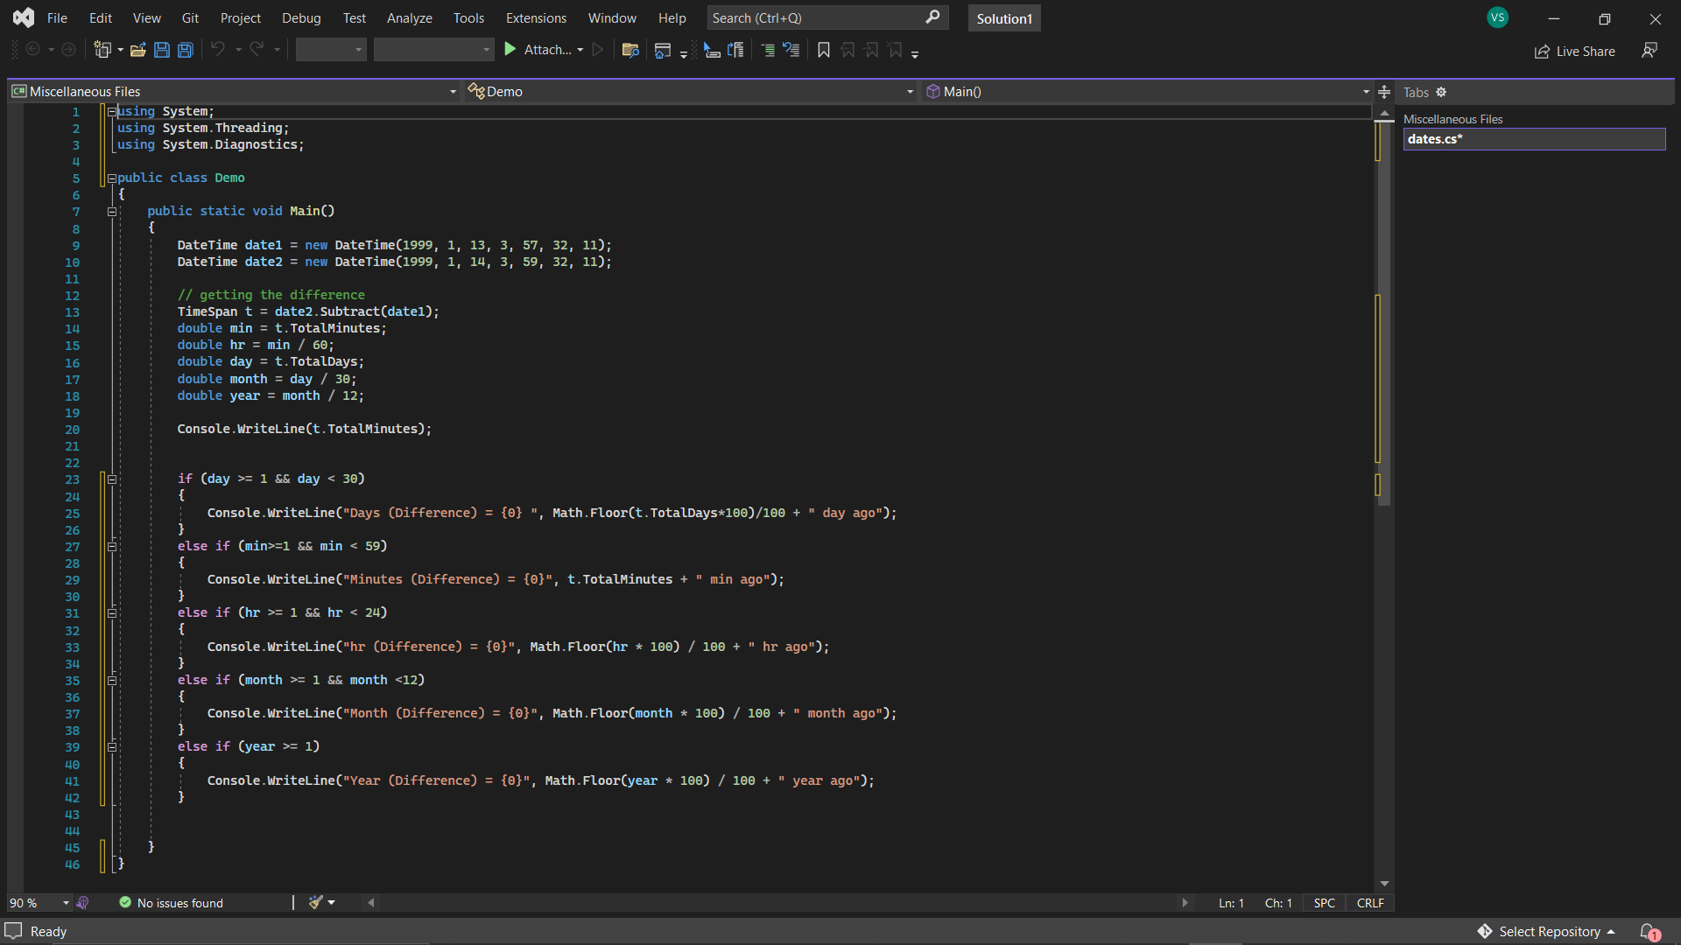

Output:-

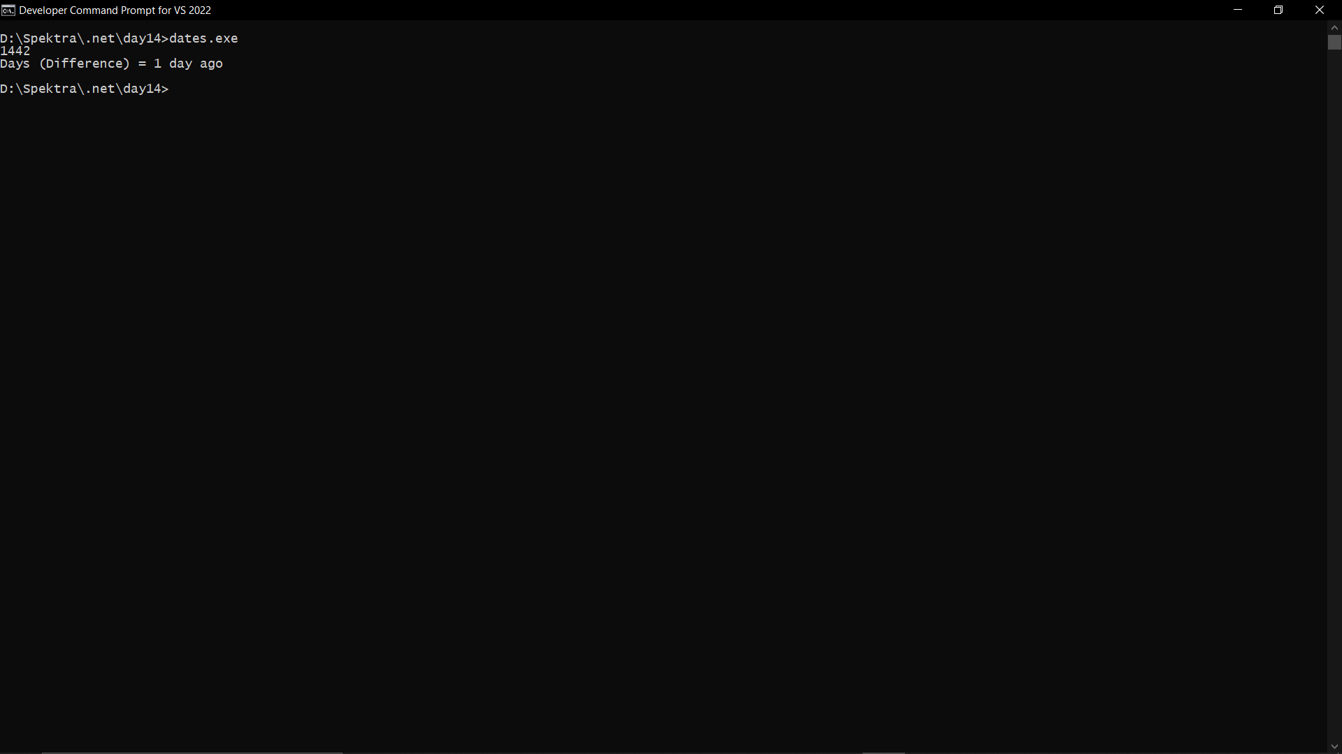

1. Write a program in C# Sharp to create and read last n number of lines of a file. [Go to the editor](https://www.w3resource.com/csharp-exercises/file-handling/index.php#editorr)

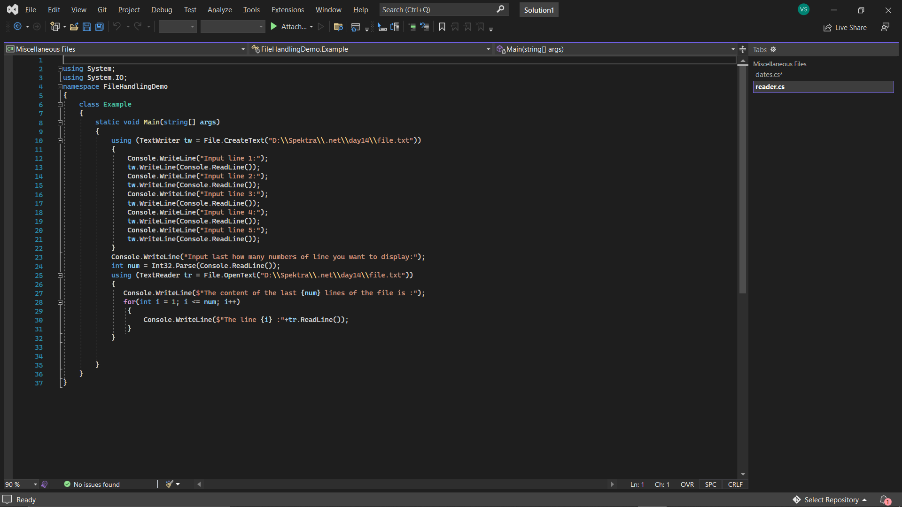

Output:-

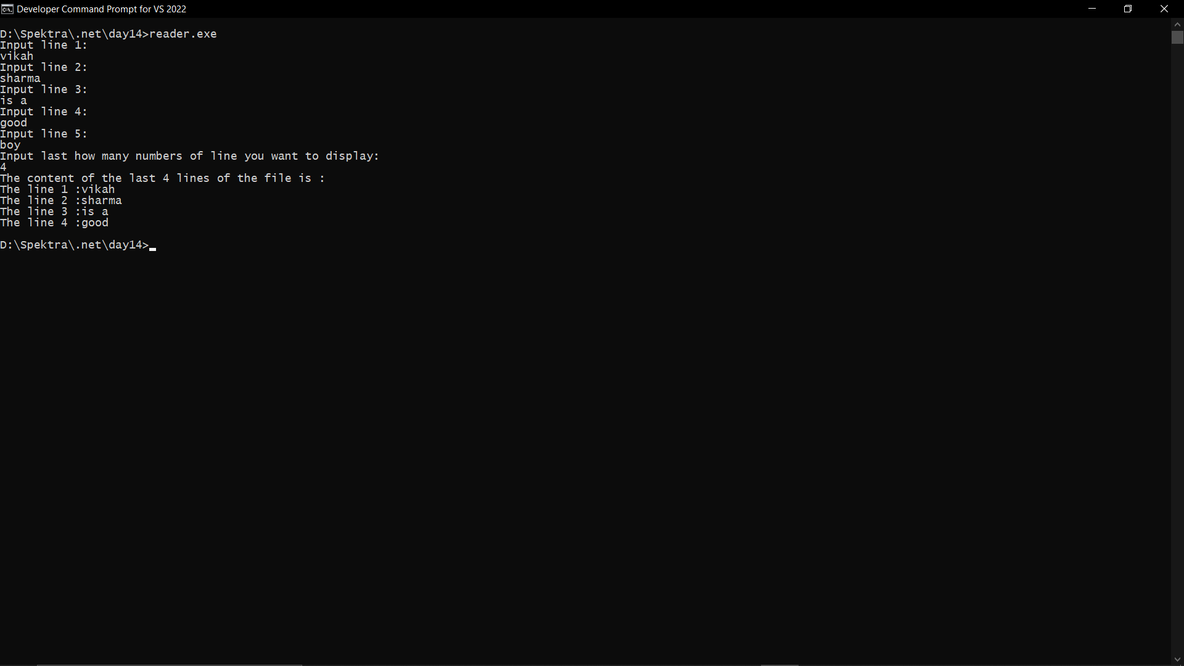

1. Write a function: that, given an array A of N integers, returns the smallest positive integer (greater than 0) that does not occur in A.

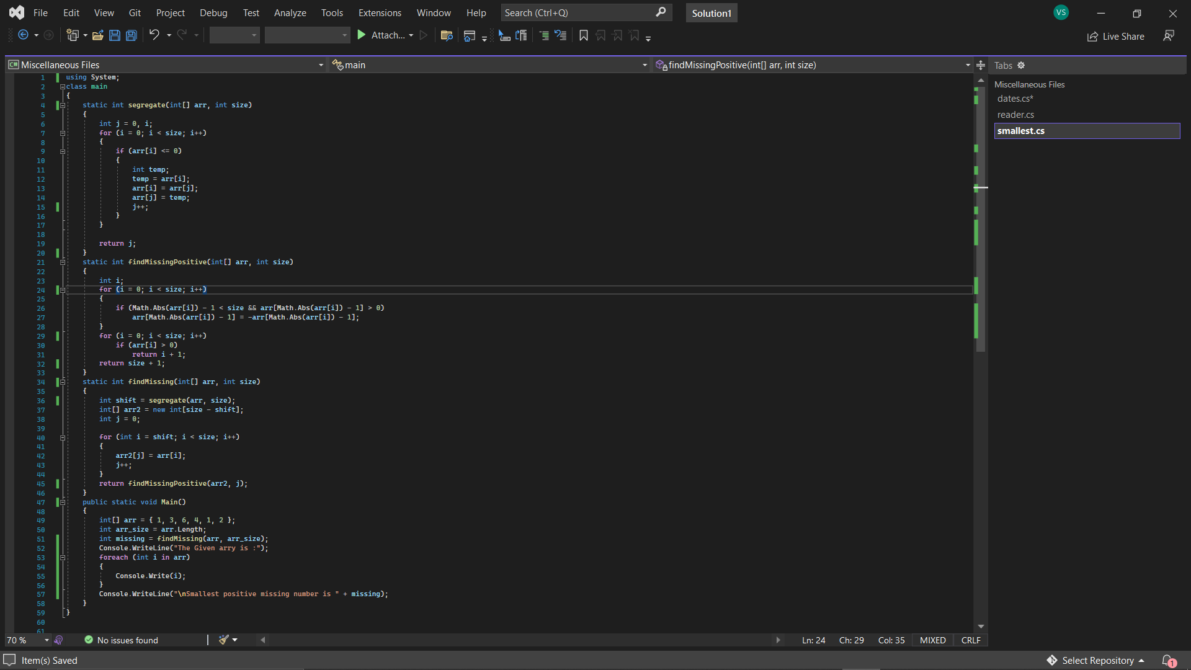

Output:-

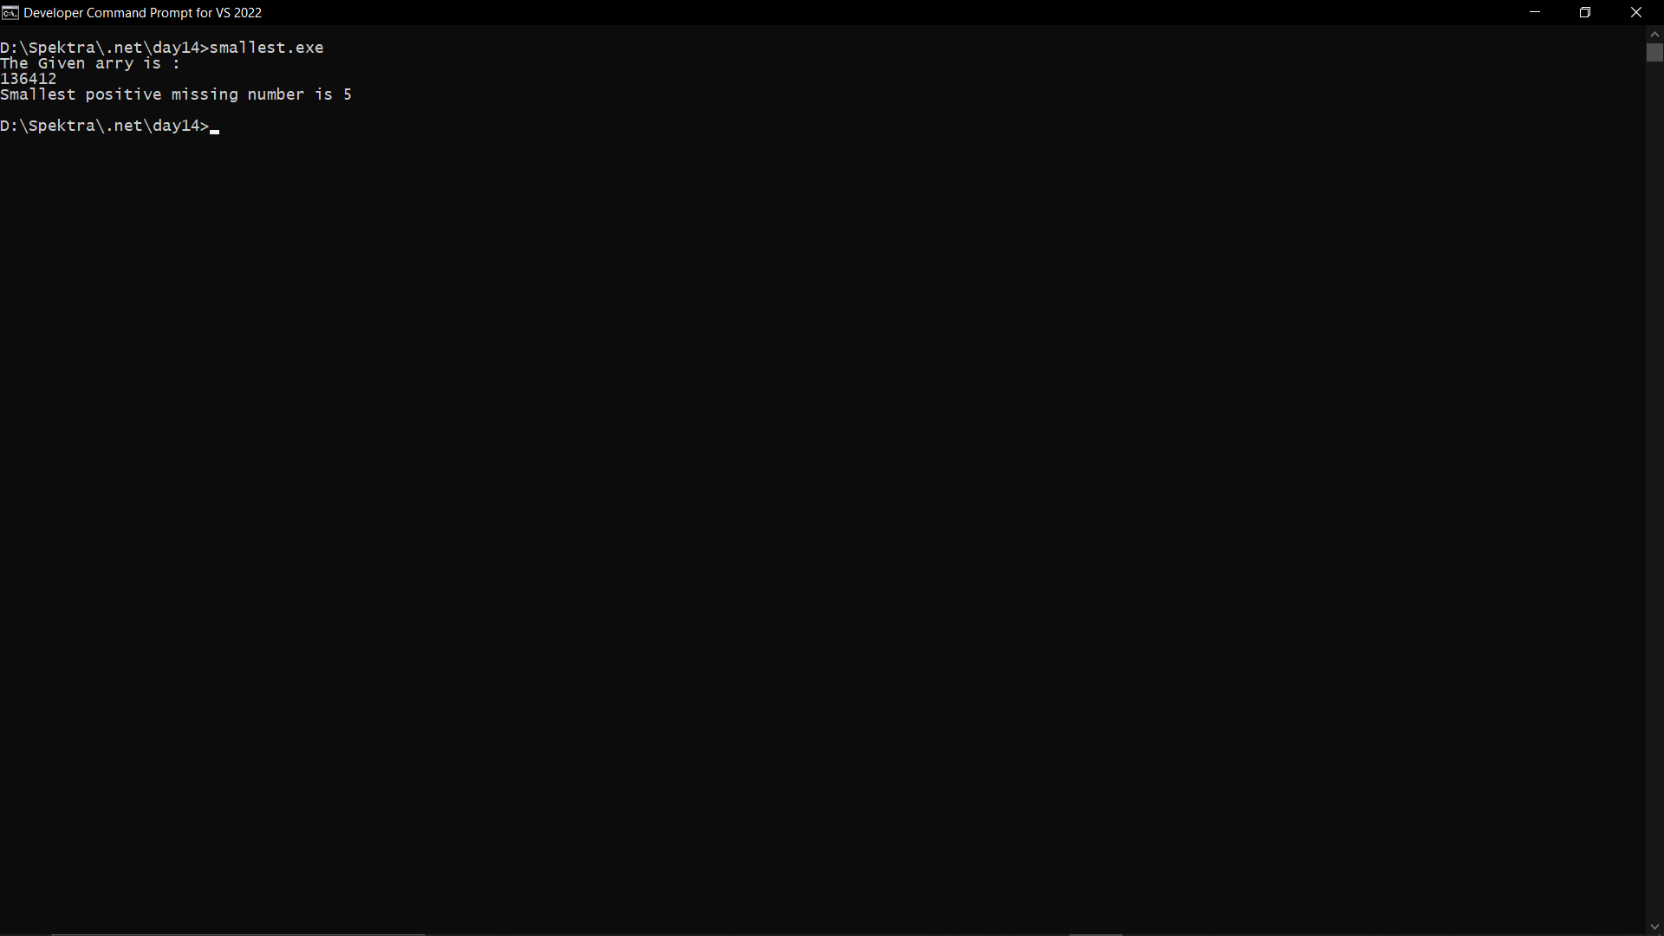

1. Reverse the ordering of words in a String

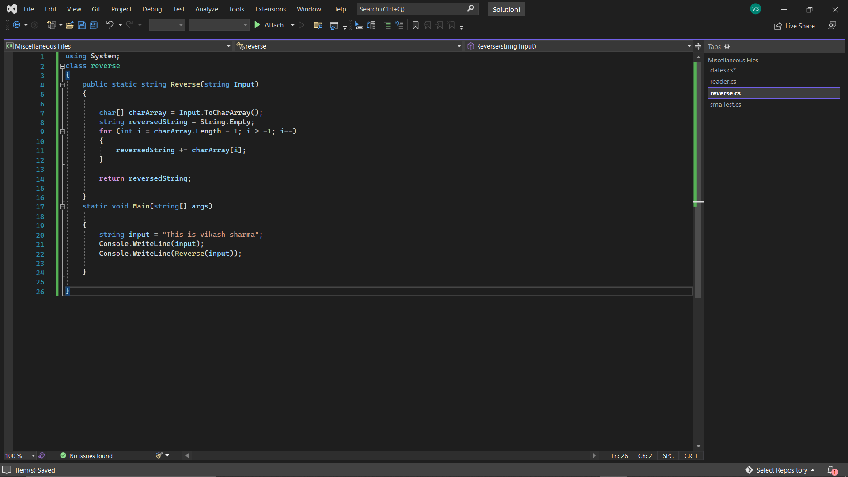

Output:-

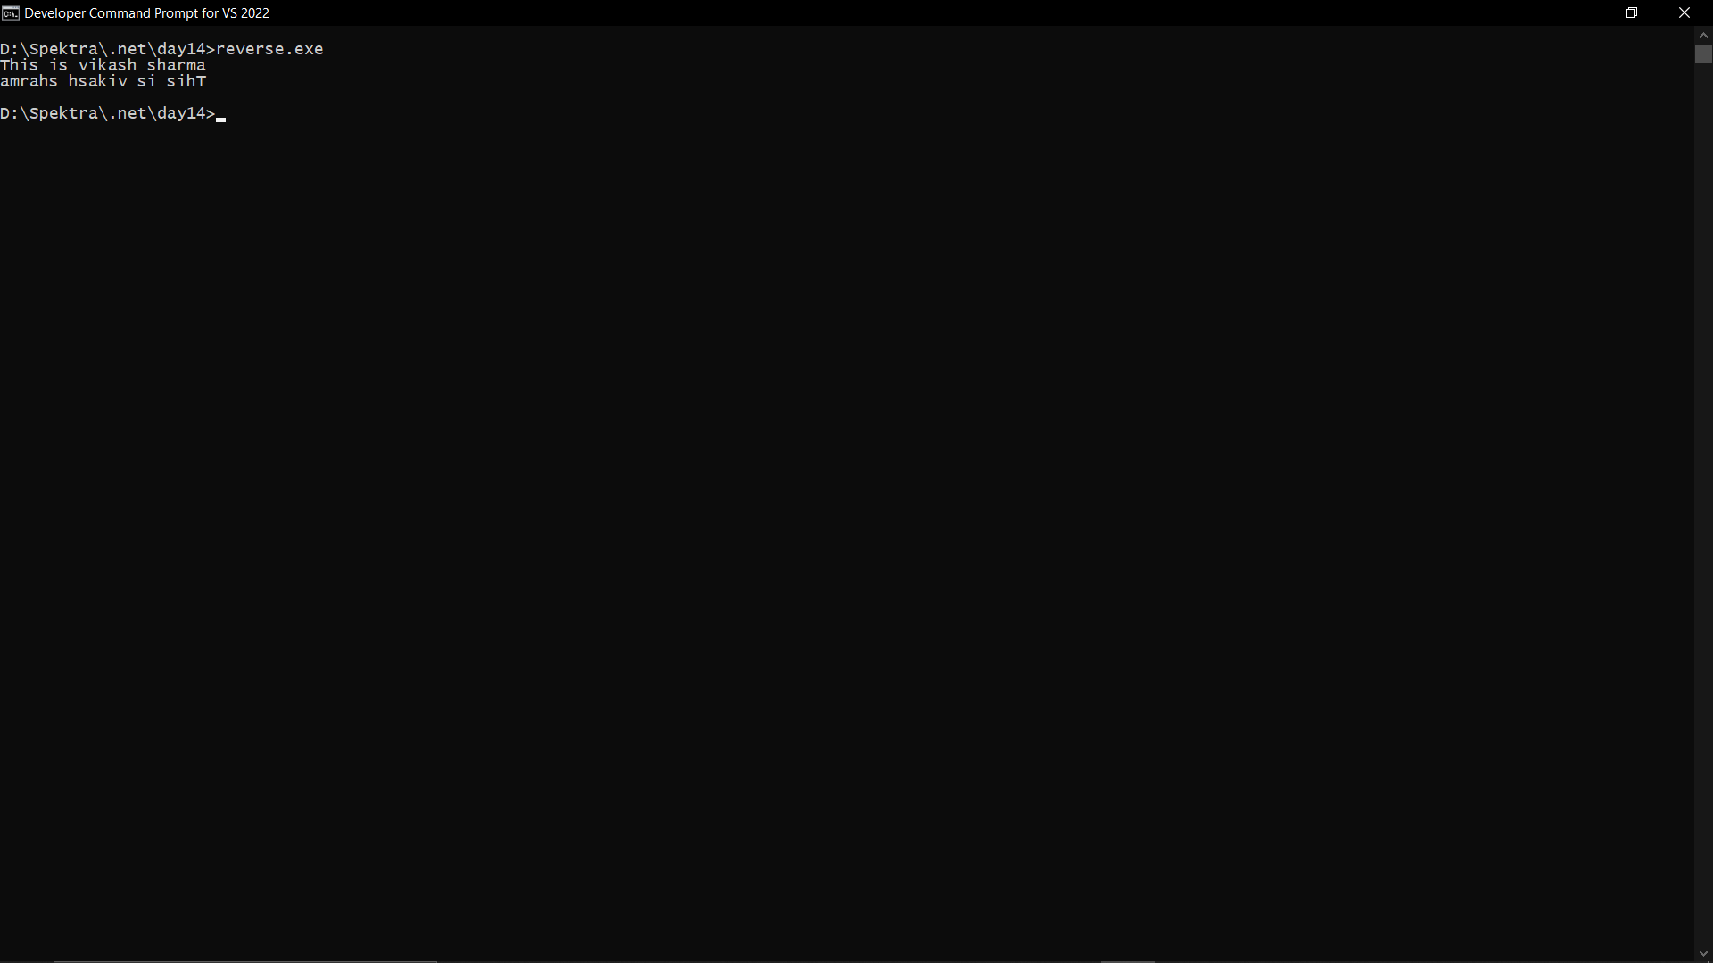

1. Given six digits, find the earliest valid time that can be displayed on a digital clock (in 24-hour format) using those digits.

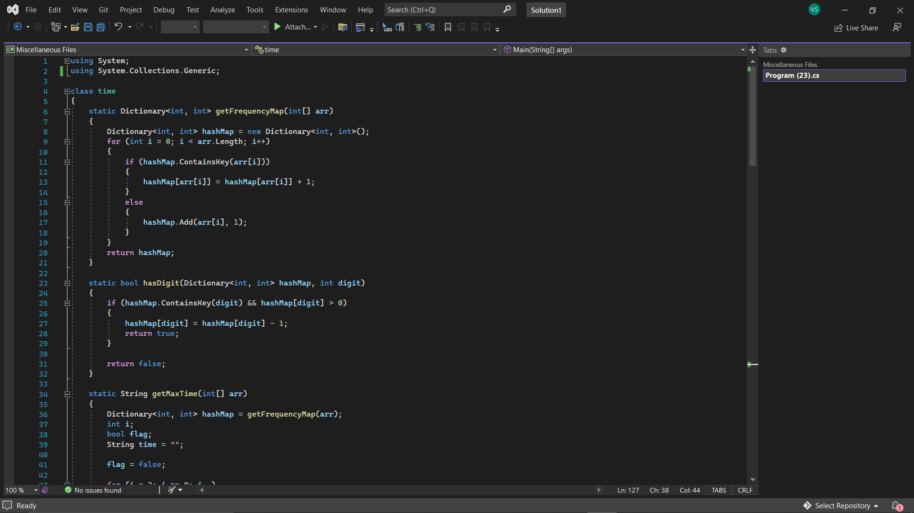

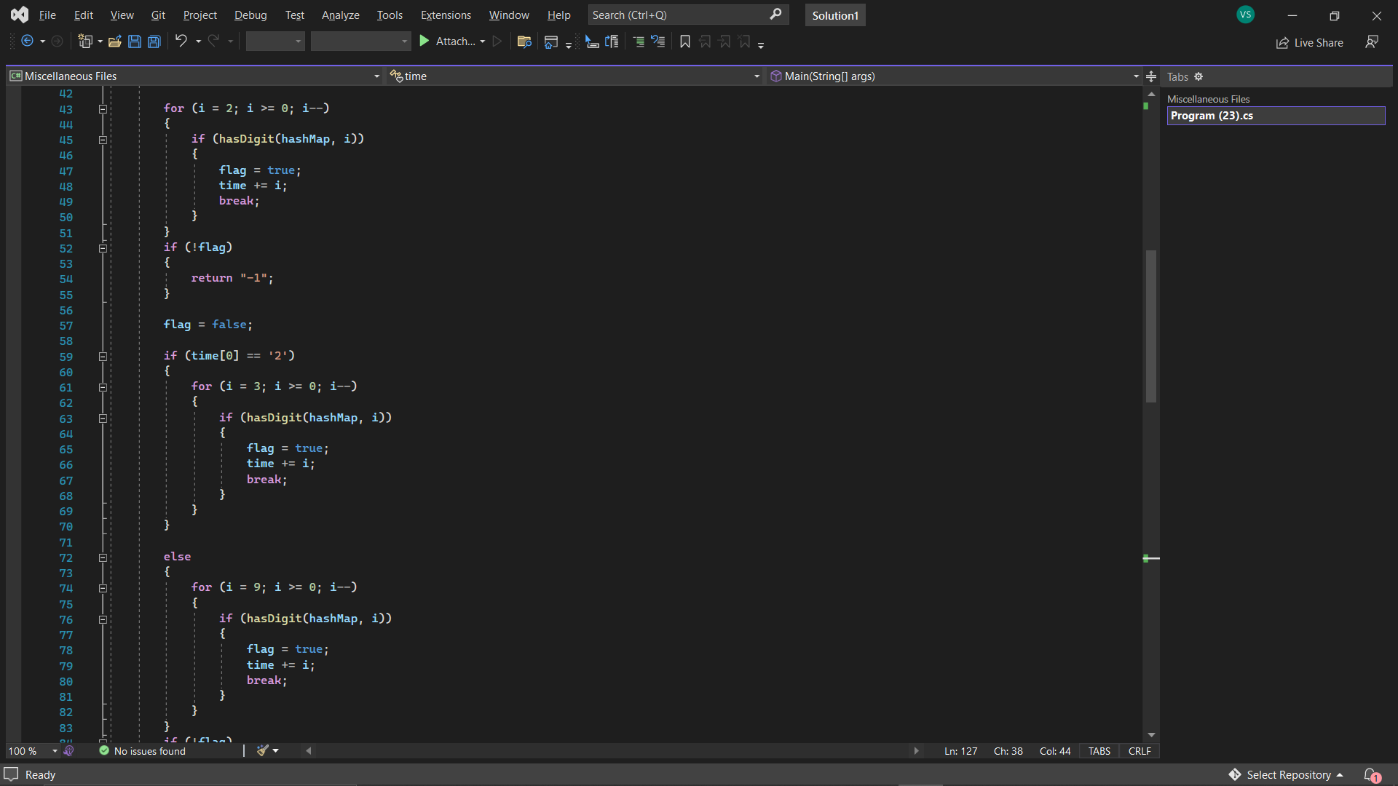

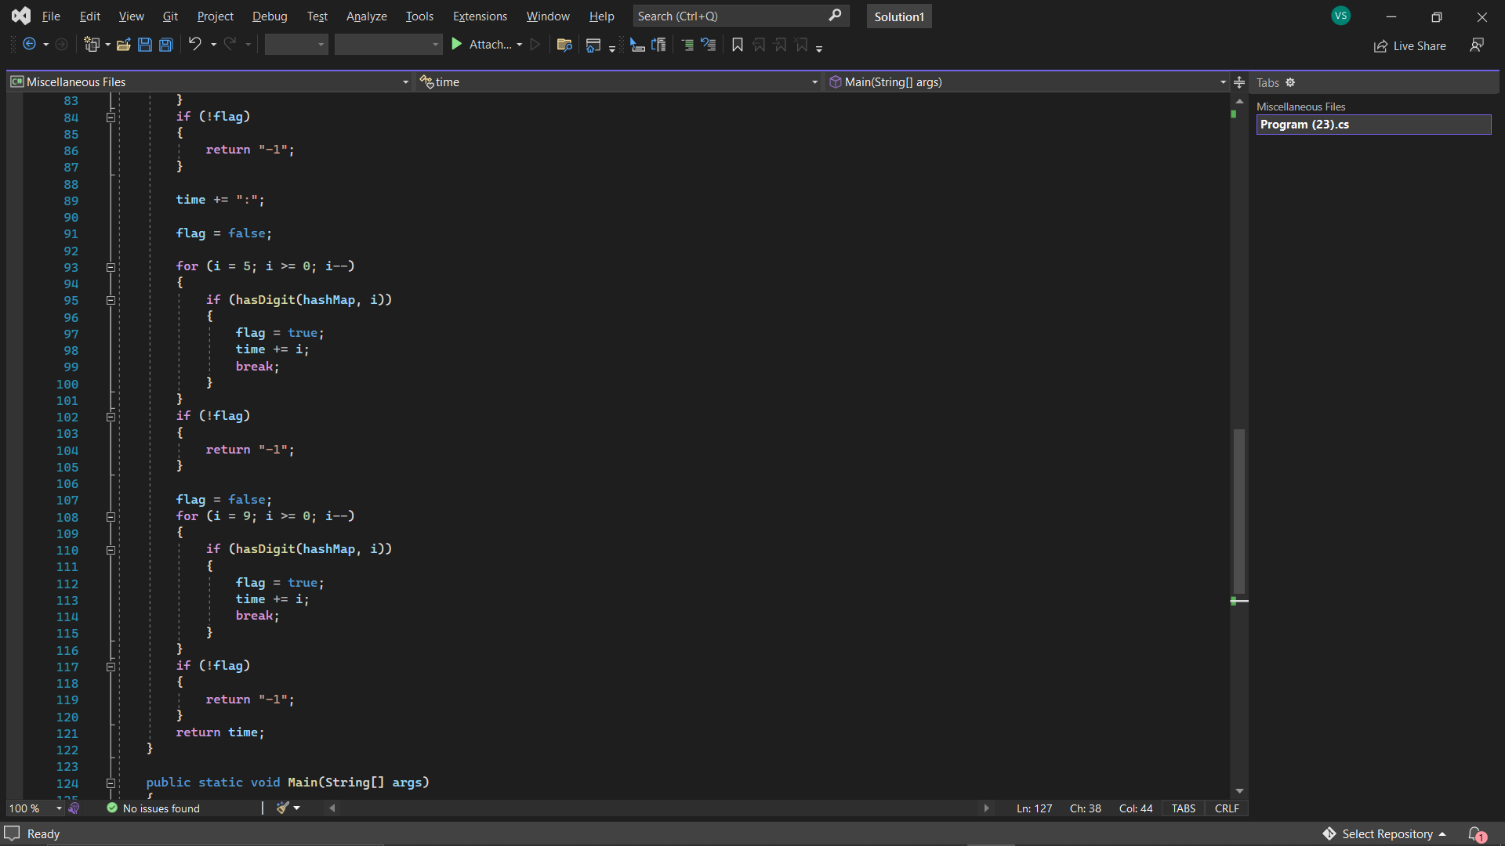

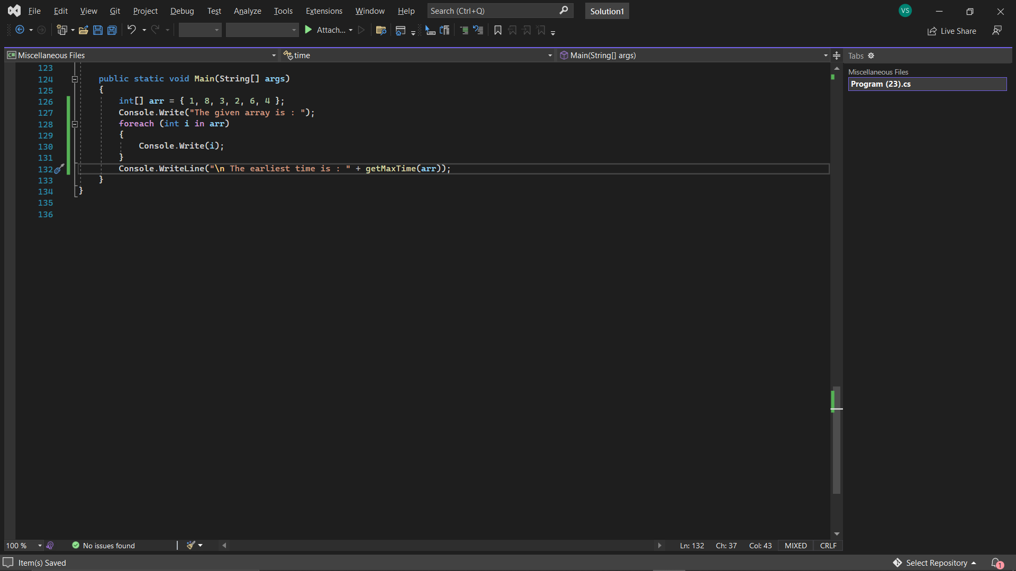

Output:-

